Name: Harshwardhan Zurunge

Roll: 16

Div: F

BI Lab Assignment 2- Study BI report tool: Installation of Power BI.

**What is Power BI?**

Power BI Desktop is a free application you install on your local computer that lets you connect to, transform, and visualize your data. With Power BI Desktop, you can connect to multiple different sources of data, and combine them (often called modeling) into a data model. This data model lets you build visuals, and collections of visuals you can share as reports, with other people inside your organization. Most users who work on business intelligence projects use Power BI Desktop to create reports, and then use the Power BI service to share their reports with others.

**Common Uses of Power BI desktop**

* Connect to data.
* Transform and clean data to create a data model.
* Create visuals, such as charts or graphs that provide visual representations of the data.
* Create reports that are collections of visuals on one or more report pages.
* Share reports with others by using the Power BI service.

Functionalities In Power BI:

These are four major building blocks of power bi

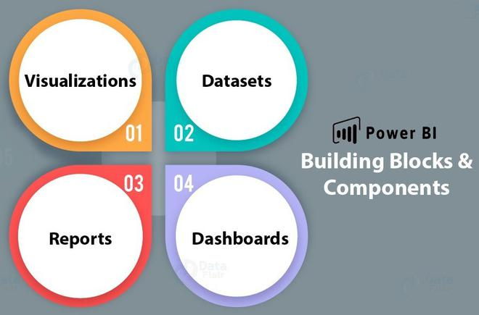

1. **Visualization**
   * A visualization is a visual representation of data, like a bar graph, pie chart, a color-coded map, or other through which you can visualize the data.
   * The following image shows a collection of different visualizations that are there in the Power BI.

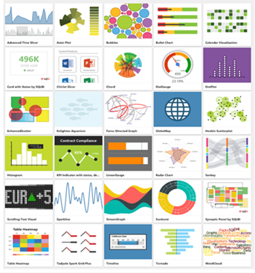

***Power BI : Visualizations***

1. **Datasets:**
   * A Dataset is a collection of data or a container of data that is used by PowerBI to create visualizations.
   * A Dataset is something which you import or connect to.
   * 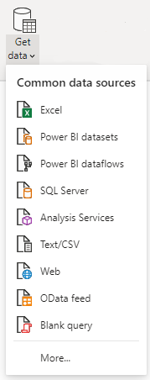Datasets can be renamed, refreshed, removes, and explored.

***Power BI : Types of Datasets***

| **S.no** | **Data Source** | **Description** |
| --- | --- | --- |
| 1. | Comma Separated Value (.csv) | A Comma Separated Values (.csv) file is a plain text file that contains a list of data. Every row can contain one or more values, which is separated by a comma. |
| 2. | Excel (.xlsx) | A workbook can have data entered manually or data, which is queried and loaded from external data sources. |
| 3. | Databases via SQL Server | You can connect directly to SQL Server Analysis Services Relational model databases. |
| 4. | Databases on Cloud | You can connect live to Azure SQL Database, Azure SQL Data Warehouse, etc to get databases. |
| 5. | Power BI (.pbi) | You can use Power BI Desktop to query and load data from external data sources. |

1. **Reports:**
   * A report is one or more pages of interactive visuals, text, and graphics that makes up a single report.
   * All of the visualizations in a report come from a single dataset.

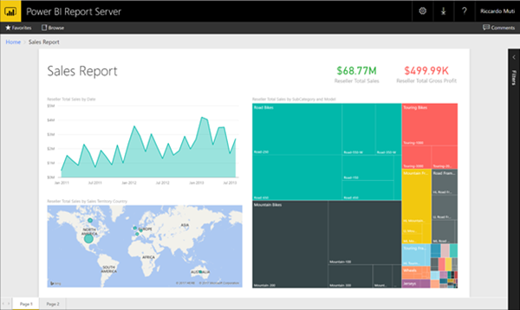

***Power BI : Reports***

1. **Dashboards:**
   * A dashboard represents a customized view of some subset of the underlying dataset(s).
   * A dashboard is a single canvas that has tiles, graphics, and text.
   * Purpose of Dashboards is to
     + get all the info at one place, needed to make decisions.
     + to monitor the most-important info about your business.
     + to ensure all colleagues are on the same page.
     + to monitor the growth of a business or product.

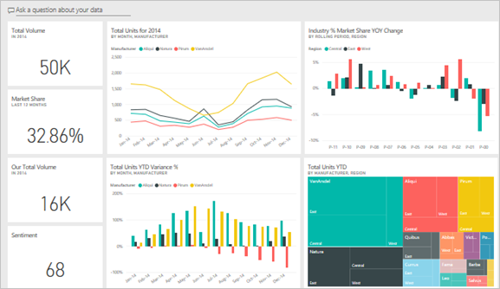

***Power BI : Dashboards***

**Installing Power BI on windows**

**There are two ways to install Microsoft power BI in windows:**

* 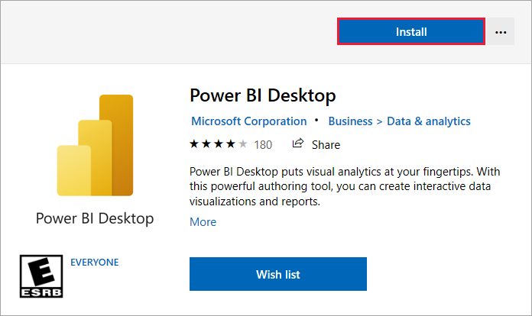**Microsoft Store**
* **Downloading an exe directly from the website**

**Step 1:**Visit the[official website](https://powerbi.microsoft.com/en-us/downloads/) on any web browser.

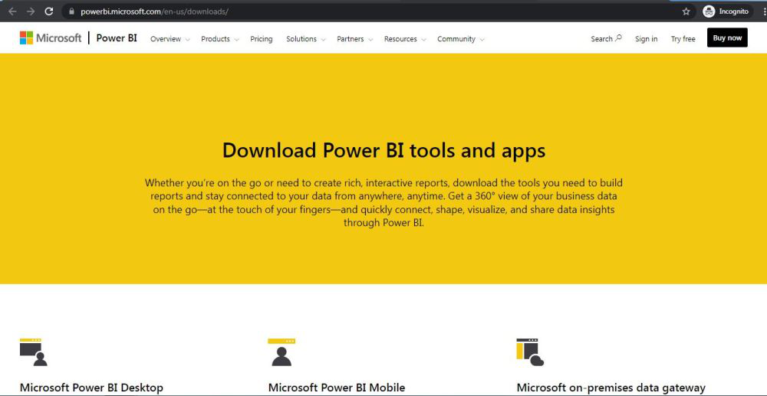

**Step 2:** Click on Microsoft Power BI desktop application.

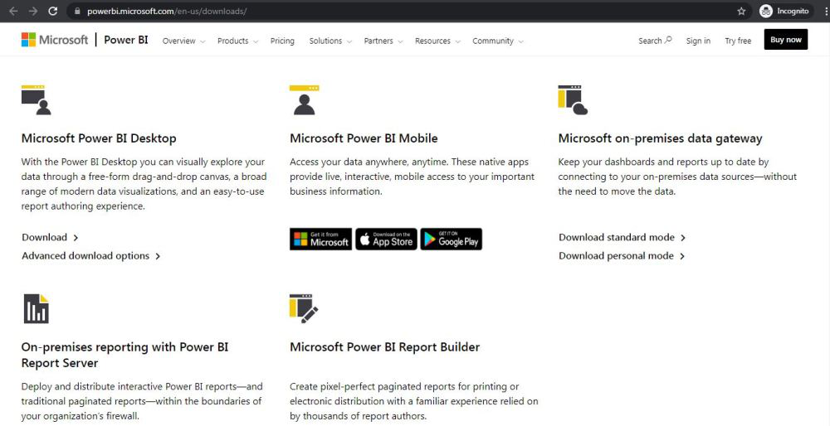

**Step 3:** Next webpage will open, click on Download Button.

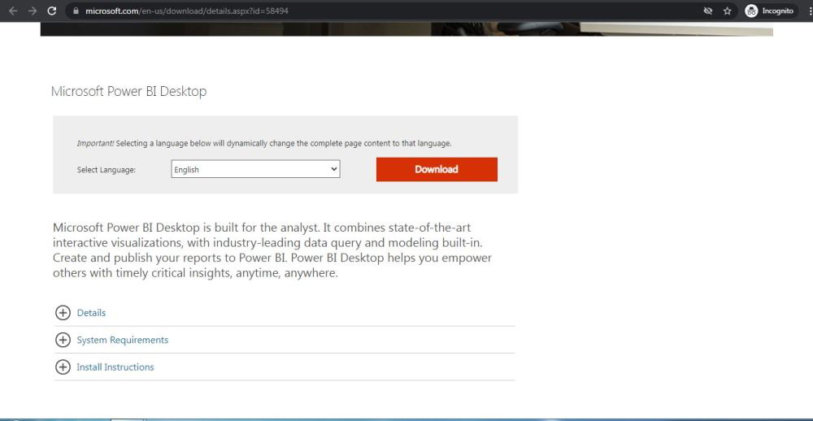

**Step 4:**On the next webpage choose the setup option according to your system configuration, let’s take the first setup, click on the Next button. Downloading of the executable file will start shortly. It is a big  361.7 MB file that will take some minutes.

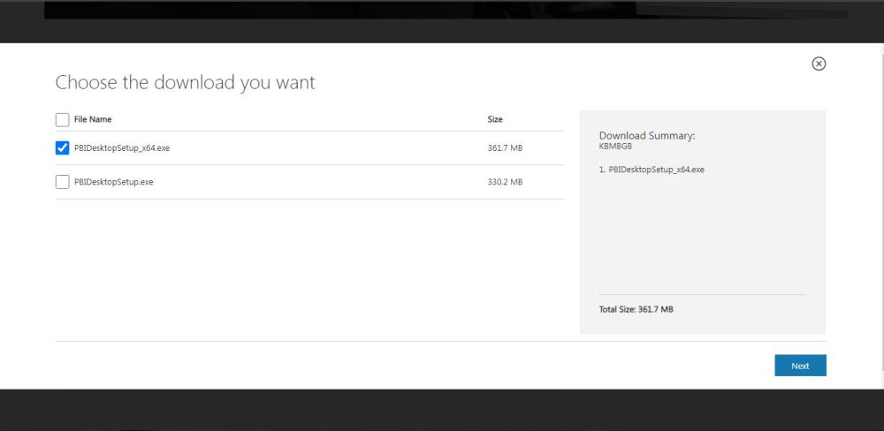

**Step 5:** Now check for the executable file in downloads in your system and run it.

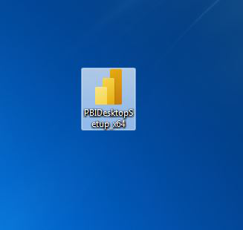

**Step 6:**It will prompt confirmation to run the file on your system. Click on Run.

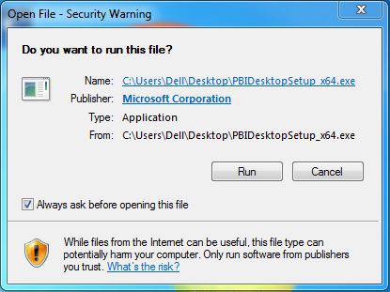

**Step 7:** Next screen will appear, select language, and click on Next.

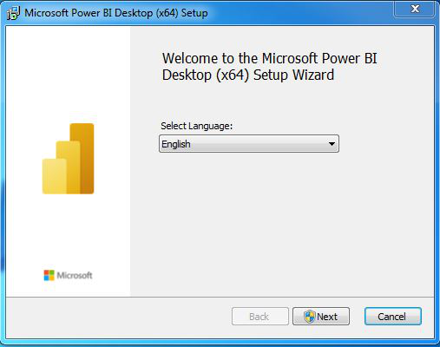

**Step 8:**It will prompt confirmation to make changes to your system. Click on Yes.

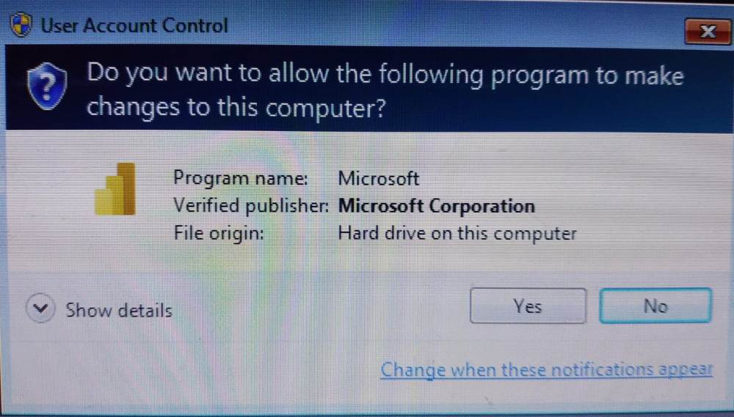

**Step 9:**The system will prepare for installation.

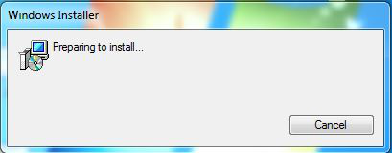

**Step 10:**Setup screen will appear, click on Next.

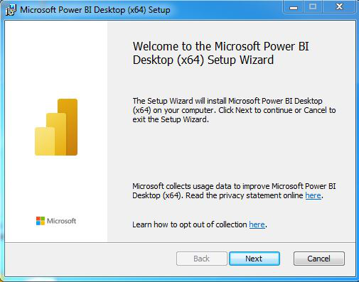

**Step 11:**The next screen will be of License Agreement, check the box, I accept the terms in License Agreement and click on Next.

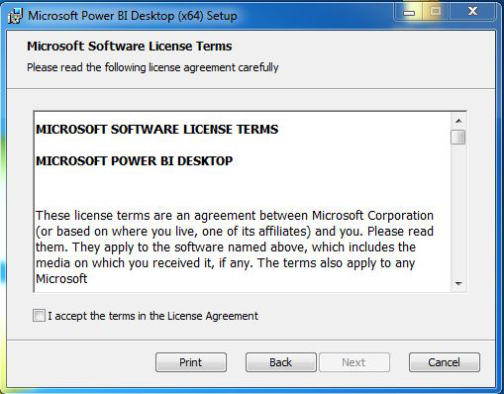

**Step 12:**Choose the destination folder and click on Next.

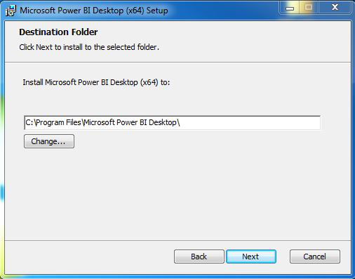

**Step 13:**The last screen will appear to click on the Install button.

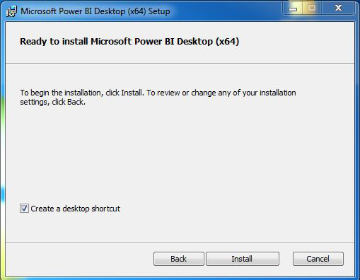

**Step 14:**After this installation process will start and will hardly take a minute to complete the installation.

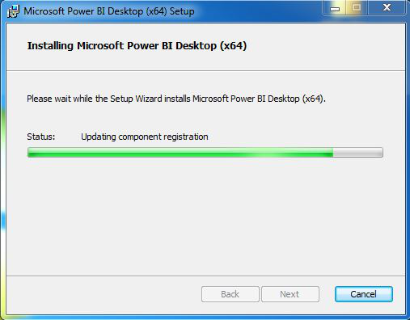

**Step 15:** Click on Finish to finish the installation process.

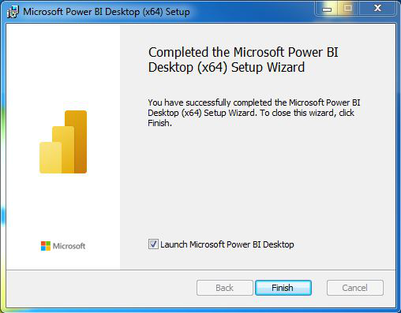

**Step 16:**Power BI is successfully installed on the system and an icon is created on the desktop.

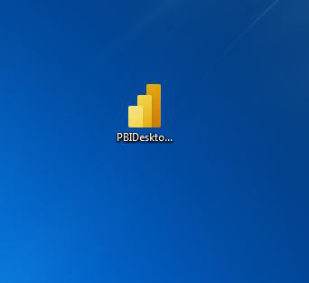

**Step 17:**Run the software and see the interface.

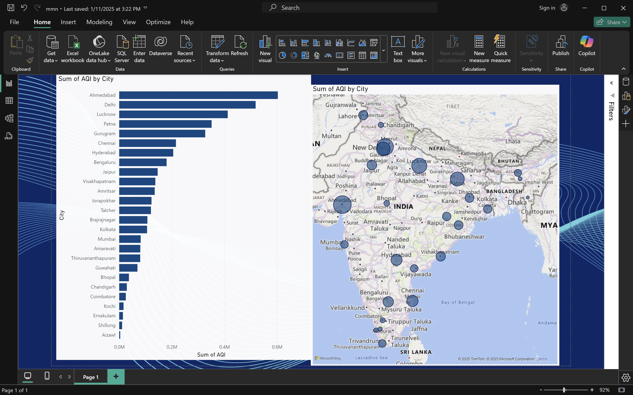

Change this preview feature setting as well

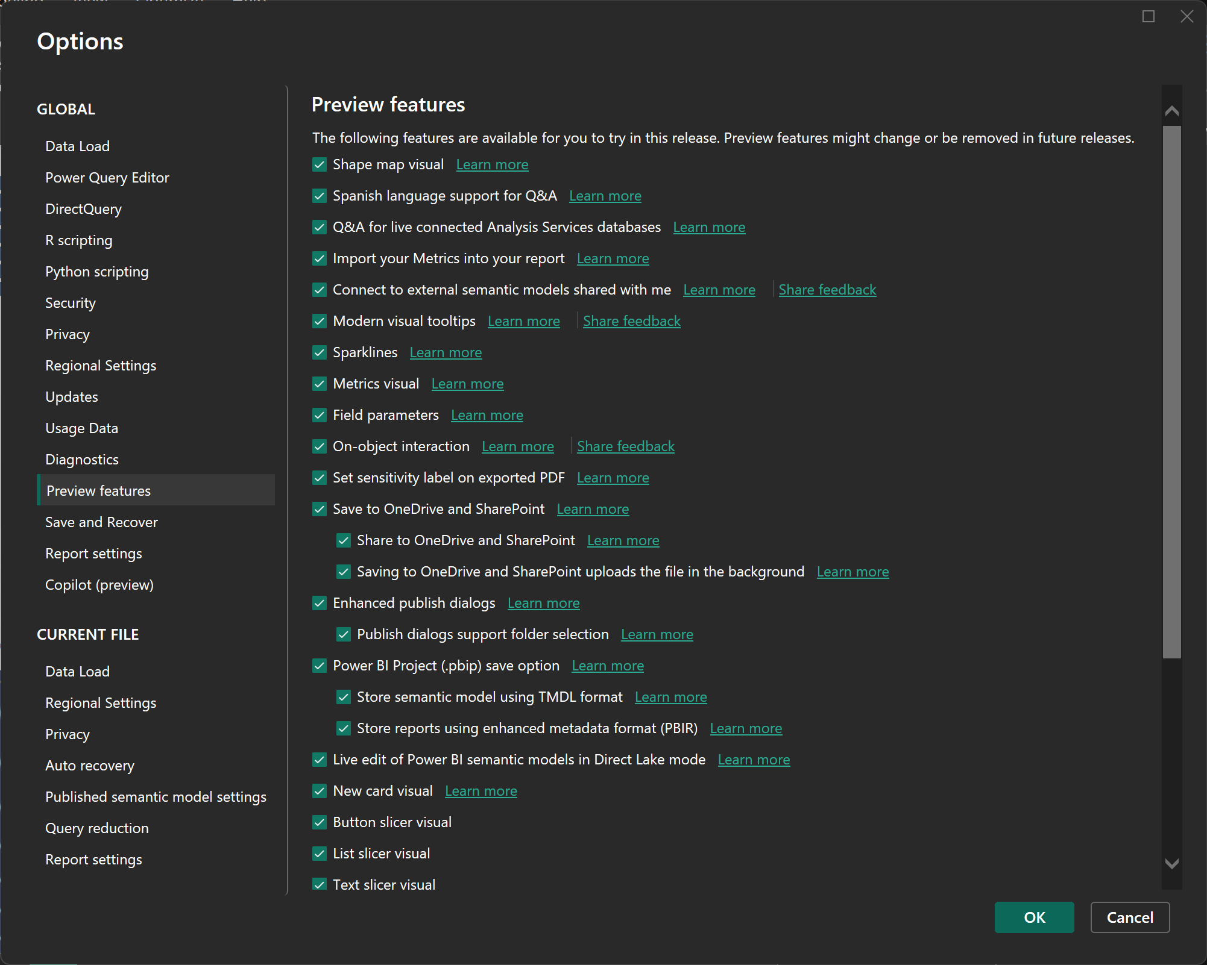

**Conclusion**

Power BI is a versatile and user-friendly business intelligence tool that empowers organizations to transform raw data into meaningful insights. With its robust data connectivity, interactive visualizations, advanced analytics, and seamless integration with the Microsoft ecosystem, Power BI caters to a wide range of users, from beginners to advanced data analysts. Its ability to handle real-time data, AI-powered insights, and collaboration features make it a valuable asset for data-driven decision-making. Whether for small businesses or large enterprises, Power BI offers a cost-effective solution for creating impactful dashboards and reports, fostering a culture of data-driven growth.9